Q5)

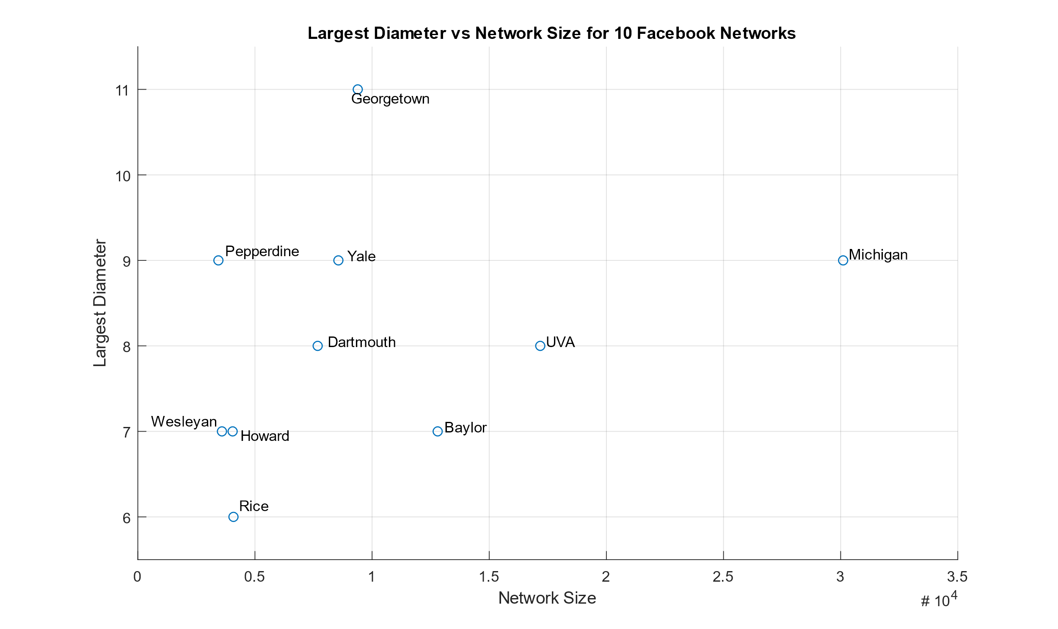

Figure 1: Largest Diameter vs Network Size for 10 Facebook Networks

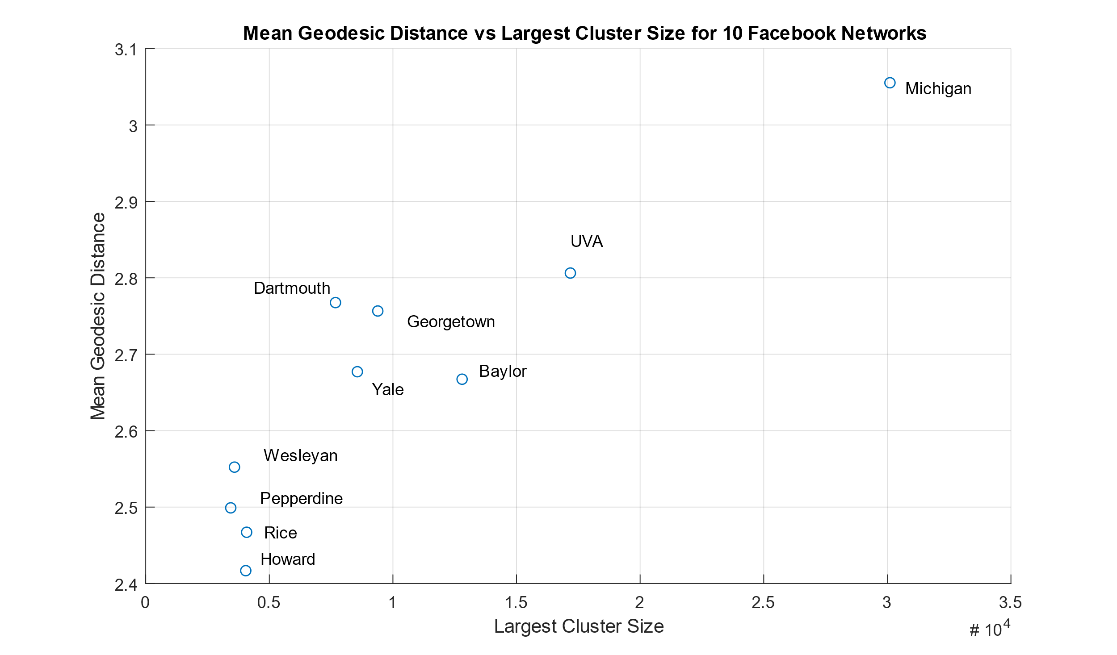

Figure 2: Mean Geodesic Distance vs Largest Cluster Size for 10 Facebook Networks

I believe the diameter of Facebook has decreased relative to these values as social media is much more prevalent today. As such, it is more likely that there will be more connections online than previously. With more connections being made, the likelihood of being able to traverse a cluster by crossing fewer connections increases. Additionally, even though people may no longer be in active contact, people do not seem to actively delete contacts as often as they add contacts so there is likely to be a net gain in connections. Thus, the diameter of Facebook has likely decreased.